Go routine

go routine has its own call stack is it true?
Yes, that is absolutely true. One of the reasons Go can handle thousands (or even millions) of goroutines simultaneously is how it manages these call stacks.
Here is the breakdown of how they work compared to traditional threads:
1. Dynamic Size (The "Small Start")
Unlike traditional OS threads which usually have a fixed, large stack (often 1MB or 2MB), a goroutine starts with a very small stack—typically only 2KB.
- Why? This tiny footprint allows you to spawn massive numbers of goroutines without exhausting your RAM.

2. Stack Growing and Shrinking
Because 2KB isn't much, Go has to be flexible.
- Growing: When a goroutine is about to exceed its current stack space (e.g., calling a deeply nested function), the Go runtime allocates a new, larger segment of memory and moves the stack there.
- Shrinking: If the goroutine finishes those intensive tasks and the stack is mostly empty, the runtime can shrink it back down to save memory.

3. Managed by the Runtime (Not the OS)
Traditional threads are managed by the Operating System. Goroutines are managed by the Go Runtime.
- The OS is "blind" to goroutines; it only sees the few OS threads that Go uses to multiplex all those goroutines.
- Because the Go runtime manages the stacks, it can move them around in memory efficiently—something an OS thread stack cannot do easily

Feature | OS Thread | Goroutine
Initial Stack Size | Fixed (~1-2MB) | Dynamic (~2KB)
Management | Operating System | Go Runtime
Creation Cost | Expensive (System call) | Very Cheap
Switching Cost | Slow (Context switch) | Fast (Scheduled by Go)

A Quick Clarification: Stack vs. Heap
While each goroutine has its own stack (for local variables and function calls), they all share the same heap. If a variable "escapes" the stack (for example, if a function returns a pointer to a local variable), that data is moved to the heap so other goroutines can potentially access it.

What about java threads vs go routines with respect to stack size?
The comparison between Java threads (Platform Threads) and Go routines is a classic study in memory efficiency. While both represent a path of execution, they handle their memory "budgets" very differently.
1. The Java Platform Thread (The "Heavyweight")
Traditionally, a Java thread is a thin wrapper around an Operating System (OS) thread.
- Fixed Stack Size: By default, a Java thread usually allocates 1MB for its stack (though this can be adjusted with the -Xss flag).
- The Problem with 1MB: Because the OS manages these threads, the memory must be allocated upfront and remain contiguous. If you have 1,000 threads, you've already spent 1GB of RAM just on stacks, even if those threads aren't doing anything.
- The "Wall": This is why Java applications often hit a "thread limit." You simply run out of memory if you try to spawn 100,000 threads.

2. The Go Routine (The "Lightweight")
Go routines are "user-space" threads managed by the Go runtime, not the OS.
- Segmented/Copying Stacks: A goroutine starts with a tiny stack of 2KB.
- Dynamic Growth: If a goroutine needs more space (e.g., deep recursion), the Go runtime creates a new, larger stack and copies the old data over. It can grow up to 1GB (on 64-bit systems), but it only uses what it needs right now.
- Efficiency: You can run millions of goroutines on a standard laptop because their combined initial memory footprint is negligible compared to Java's 1MB-per-thread rule

Feature | Java Platform Threads | Go Routines
Initial Stack Size | ~1MB (Large & Fixed) | ~2KB (Small & Dynamic)
Memory Limit | Harder to scale (RAM-heavy) | High scalability (Millions of units)
Scaling | Limited by OS resources | Limited by RAM availability
Management | OS Kernel | Go Runtime (M:N Scheduler)

A Note on Java "Project Loom" (Virtual Threads)
It is important to note that modern Java (Java 19+) introduced Virtual Threads.
- Virtual Threads act very similarly to Goroutines. They are "mounted" onto platform threads and have stacks that are stored in the heap rather than fixed OS memory.
- This allows Java to finally compete with Go's "millions of threads" model by moving away from the rigid 1MB fixed-stack requirement for high-concurrency tasks.

in case of java threads, when i create new thread what will happen with context of go routine ?
When you compare creating a Java Thread vs. a Go Routine, you are looking at two different levels of the "computer sandwich." Java (traditionally) creates something the Operating System manages, while Go creates something it manages itself.
Here is what happens when you create a new thread in both worlds:

1. Java (Platform) Thread: "Requesting a New House"
In traditional Java (pre-Virtual Threads), a thread is a Platform Thread.
- OS Intervention: When you call new Thread().start(), the JVM makes a system call to the Operating System (Linux, Windows, etc.).
- The "Heavy" Stack: The OS allocates a fixed block of memory—usually 1MB—for that thread's call stack immediately.
- The Link: There is a 1:1 relationship. 1 Java Thread = 1 OS Thread.
- Context Switching: Because the OS is in charge, switching between two Java threads requires a "Kernel Context Switch," which is expensive in terms of CPU cycles.

2. Go Routine: "Adding a Task to the List"
In Go, a goroutine is a User-space Thread.
- Internal Management: When you use the go keyword, the Go runtime handles it. The Operating System has no idea a new goroutine was even created.
- The "Light" Stack: Instead of 1MB, Go allocates a tiny 2KB stack.
- The "M:N" Model: Go uses an M:N scheduler. It takes $M$ goroutines and maps them onto $N$ OS threads (where $N$ is usually the number of CPU cores you have).
- Cheap Switching: If one goroutine stops (e.g., waiting for a channel), the Go scheduler simply swaps in another goroutine on that same OS thread. This happens in "User-space," meaning it's much faster than an OS context switch.

Action | Java (Platform Thread) | Go (Routine)
Who creates it? | The Operating System (Kernel) | The Go Runtime
Initial Memory | 1MB (Fixed) | 2KB (Dynamic)
Creation Speed | Slower (System call required) | Extremely Fast (Internal)
Maximum Count | Thousands (Limited by RAM) | Millions (Very scalable)
Context Switch | Heavy (Kernel level) | Light (User level)

is it main is running by a go routine?
Yes, absolutely. In Go, the main function is executed by a goroutine. We call this the Main Goroutine.
When your program starts, the Go runtime performs a few specific steps to get that first goroutine running:
1. The Birth of the Main Goroutine
The Go runtime is initialized first. Once it’s ready, it creates the very first goroutine and tasks it with running your main.main function.

2. The "Boss" Goroutine
The Main Goroutine is special because it controls the lifecycle of the entire program:
- Launching Others: Any other goroutines you start (using the go keyword) are "children" of this environment.
- The "Instant Exit" Rule: If the Main Goroutine finishes its work and returns, the entire program terminates immediately. It does not wait for other goroutines to finish unless you explicitly tell it to (using sync.WaitGroup or channels).

3. Verification: Seeing is Believing
You can actually prove this by checking the "ID" or stack trace inside your main function. If you run a stack trace, you'll see it listed as goroutine 1.

package main

import (
"fmt"
"runtime"
)

func main() {
// This will print the stack trace of the current execution
buf := make([]byte, 1024)
n := runtime.Stack(buf, false)
fmt.Printf("%s\n", buf[:n])
}

Comparison: Main Goroutine vs. Others
Feature | Main Goroutine | Any Other Goroutine (go func())
Created By | The Go Runtime at startup | The programmer using the go keyword
ID | Always 1 | Incrementing (2, 3, 4...)
Program Exit | If it dies, the program dies | Can die silently without stopping the program
Initial Stack | 2KB (Standard) | 2KB (Standard)

Gemini said
Yes, absolutely. In Go, the main function is executed by a goroutine. We call this the Main Goroutine.
When your program starts, the Go runtime performs a few specific steps to get that first goroutine running:
1. The Birth of the Main Goroutine
The Go runtime is initialized first. Once it’s ready, it creates the very first goroutine and tasks it with running your main.main function.
2. The "Boss" Goroutine
The Main Goroutine is special because it controls the lifecycle of the entire program:
- Launching Others: Any other goroutines you start (using the go keyword) are "children" of this environment.
- The "Instant Exit" Rule: If the Main Goroutine finishes its work and returns, the entire program terminates immediately. It does not wait for other goroutines to finish unless you explicitly tell it to (using sync.WaitGroup or channels).
3. Verification: Seeing is Believing
You can actually prove this by checking the "ID" or stack trace inside your main function. If you run a stack trace, you'll see it listed as goroutine 1.
Go
package main

import (
"fmt"
"runtime"
)

func main() {
// This will print the stack trace of the current execution
buf := make([]byte, 1024)
n := runtime.Stack(buf, false)
fmt.Printf("%s\n", buf[:n])
}
If you run this, the first line of the output will likely be: goroutine 1 [running]:

Comparison: Main Goroutine vs. Others
Feature | Main Goroutine | Any Other Goroutine (go func())
Created By | The Go Runtime at startup | The programmer using the go keyword
ID | Always 1 | Incrementing (2, 3, 4...)
Program Exit | If it dies, the program dies | Can die silently without stopping the program
Initial Stack | 2KB (Standard) | 2KB (Standard)

Why this matters
Because main is just another goroutine, it follows all the rules we discussed:
- It has its own 2KB stack.
- Its stack will grow if you call many functions.
- It can be preempted (paused) by the scheduler to let other goroutines run

Since the program exits when main finishes, would you like to see how to use a WaitGroup to make main wait for your other goroutines to finish their work?

To make the main goroutine wait for others, we use the sync package. Think of it like a counter: you increment it when a worker starts and decrement it when they finish. The "Boss" (Main) waits until that counter hits zero.
The sync.WaitGroup Pattern
Here is the most common way to handle this:
package main
import (
"fmt"
"sync"
"time"
)
func worker(id int, wg *sync.WaitGroup) {
// 3. Decrement the counter when the function returns
defer wg.Done()
fmt.Printf("Worker %d starting...\n", id)
time.Sleep(time.Second) // Simulate work
fmt.Printf("Worker %d done!\n", id)
}
func main() {
var wg sync.WaitGroup
for i := 1; i <= 3; i++ {
// 1. Increment the counter for each goroutine
wg.Add(1)
go worker(i, &wg)
}
// 2. Block the 'main' goroutine until the counter is 0
fmt.Println("Main: Waiting for workers...")
wg.Wait()
fmt.Println("Main: All workers finished. Exiting.")
}
Critical Details to Remember
- Pass by Pointer: Always pass the WaitGroup to functions as a pointer (*sync.WaitGroup). If you pass it by value, the function gets a copy, and the Done() call won't affect the original counter in main, causing a deadlock!
- The Add Location: Always call wg.Add(1) before the go statement. If you put it inside the goroutine, there is a tiny "race condition" where main might reach wg.Wait() before the new goroutine has actually started and called Add.
- defer wg.Done(): Using defer ensures that even if the worker function crashes or returns early due to an error, the counter is still decremented.
What happens if you forget wg.Wait()?
The main goroutine will hit the end of the main() function and exit immediately. Because the main goroutine is the "heartbeat" of the process, the OS will kill all other goroutines instantly, even if they were right in the middle of important work.
Summary Table: WaitGroup Methods
Method | What it does
Add(int) | Increases the counter (usually by 1).
Done() | Decreases the counter by 1.
Wait() | Pauses the current goroutine until the counter is 0.

Since we are talking about multiple goroutines running at once, would you like to know how to handle the situation where two goroutines try to update the same variable at the exact same time (a Race Condition)?

When multiple goroutines try to access and change the same variable at the same time, you get a Race Condition. This makes your program's behavior unpredictable—sometimes it works, and sometimes it "glitches" or crashes.
In Go, there are two main ways to solve this.

With Race condition example:
package main
import (
"fmt"
"sync"
)
var counter int
func increment(wg *sync.WaitGroup) {
defer wg.Done()
counter++ // ❌ NOT atomic (this is the problem)
}
func main() {
var wg sync.WaitGroup
for i := 0; i < 1000; i++ {
wg.Add(1)
go increment(&wg)
}
wg.Wait()
fmt.Println("Final Counter:", counter)
}

without Race condition example:
package main

import (
"fmt"
"sync"
)

var (
counter int
mutex sync.Mutex // The "key"
)

func increment(wg *sync.WaitGroup) {
defer wg.Done()

mutex.Lock() // Start of Critical Section
counter++ // Only one goroutine can be here at a time
mutex.Unlock() // End of Critical Section
}

func main() {
var wg sync.WaitGroup
for i := 0; i < 1000; i++ {
wg.Add(1)
go increment(&wg)
}
wg.Wait()
fmt.Println("Final Counter:", counter)
}

2. The Atomic Package
If you are just doing simple math (like adding to an integer), using a Mutex is a bit "heavy." Go provides the sync/atomic package which uses low-level CPU instructions to ensure the operation is completed in one single, un-interruptible step.
package main
import (
"fmt"
"sync"
"sync/atomic" // 1. Import the atomic package
)
var (
// 2. Change to int64 for compatibility with atomic functions
counter int64
)
func increment(wg *sync.WaitGroup) {
defer wg.Done()
// 3. Replace mutex.Lock/Unlock with a single atomic operation.
// This adds 1 to the value at the memory address of counter.
atomic.AddInt64(&counter, 1)
}
func main() {
var wg sync.WaitGroup
for i := 0; i < 1000; i++ {
wg.Add(1)
go increment(&wg)
}
wg.Wait()
// 4. Use atomic.LoadInt64 to safely read the final value.
fmt.Println("Final Counter:", atomic.LoadInt64(&counter))
}
To update your code to use the sync/atomic package, we remove the mutex and change the int type to int64 (or uint64), as atomic operations require specific bit-sized types to map correctly to CPU instructions.
Updated Code with sync/atomic
package main

import (
"fmt"
"sync"
"sync/atomic" // 1. Import the atomic package
)

var (
// 2. Change to int64 for compatibility with atomic functions
counter int64
)

func increment(wg *sync.WaitGroup) {
defer wg.Done()

// 3. Replace mutex.Lock/Unlock with a single atomic operation.
// This adds 1 to the value at the memory address of counter.
atomic.AddInt64(&counter, 1)
}

func main() {
var wg sync.WaitGroup
for i := 0; i < 1000; i++ {
wg.Add(1)
go increment(&wg)
}
wg.Wait()

// 4. Use atomic.LoadInt64 to safely read the final value.
fmt.Println("Final Counter:", atomic.LoadInt64(&counter))
}

Key Changes Made
- Type Change: I changed counter from int to int64. The sync/atomic functions are very strict about types because they correspond to specific CPU register sizes.
- Removed Mutex: We no longer need mutex.Lock() or mutex.Unlock(). The atomic.AddInt64 function handles the "read-modify-write" cycle in one uninterruptible CPU step.
- Atomic Load: In the fmt.Println, I used atomic.LoadInt64(&counter). While a simple fmt.Println(counter) might work here because the workers are already finished (wg.Wait()), it is a "best practice" to always use atomic loads when reading a variable that is modified by other goroutines to ensure you see the most recent write from the CPU cache.

Channels:

In Go, a channel is a pipe that connects concurrent goroutines. You can send values into a channel from one goroutine and receive those values in another goroutine.
1. The Syntax
Channels are typed. A chan int can only carry integers, and a chan string can only carry strings.
- Create: ch := make(chan int)
- Send: ch <- 42 (The arrow points into the channel)
- Receive: val := <-ch (The arrow points out of the channel)
- Close: close(ch) (Tells receivers no more data is coming)

2. The Unbuffered Channel (The "Handshake")
By default, channels are unbuffered. This is the most important concept to grasp: An unbuffered channel requires both a sender and a receiver to be ready at the exact same time.
- If you try to send, the goroutine blocks (pauses) until someone receives.
- If you try to receive, the goroutine blocks until someone sends.

Basic "Ping-Pong" Code
Here is a simple example where main sends a message to a worker goroutine.
package main
import "fmt"
func main() {
messages := make(chan string)
done := make(chan bool) // Signal channel
go func() {
msg := <-messages
fmt.Println("Worker received:", msg)
done <- true // Tell main we are actually finished
}()
messages <- "Hello from Main!"
<-done // Block main here until the worker sends 'true'
fmt.Println("Main: Worker confirmed receipt. Exiting.")
}

Let’s look at Buffered Channels.
Think of an unbuffered channel like a telephone call: both people must be on the line at the same time to talk. A buffered channel is like a mailbox: you can drop off letters (data) even if the receiver isn't there, as long as the mailbox isn't full.

The Key Difference
- Unbuffered: make(chan int) -> Capacity is 0. Sends block until a receiver arrives.
- Buffered: make(chan int, 2) -> Capacity is 2. You can send 2 items without a receiver being present. The 3rd send will block.

Buffered Channel Example:
package main
import "fmt"
func main() {
// 1. Create a channel with a buffer of 10
messages := make(chan string, 10)
// 2. Send two messages.
// This DOES NOT block because there is room in the "mailbox".
messages <- "Buffered"
messages <- "Channel"
messages <- "Buffered"
messages <- "Channel"
messages <- "Buffered"
messages <- "Channel"
fmt.Println("Sent two messages to the buffer without blocking.")
// 3. Receive them
//fmt.Println(<-messages)
//fmt.Println(<-messages)
// Print everything currently in the buffer
close(messages) // Tell the loop no more data is coming
for msg := range messages {
fmt.Println(msg)
}
}
Go Concurrency Patterns: Pipelines and cancellation
Go’s concurrency primitives make it easy to construct streaming data pipelines that make efficient use of I/O and multiple CPUs.

What is a pipeline?¶
There’s no formal definition of a pipeline in Go; it’s just one of many kinds of concurrent programs. Informally, a pipeline is a series of stages connected by channels, where each stage is a group of goroutines running the same function. In each stage, the goroutines
- receive values from upstream via inbound channels
- perform some function on that data, usually producing new values
- send values downstream via outbound channels
Each stage has any number of inbound and outbound channels, except the first and last stages, which have only outbound or inbound channels, respectively. The first stage is sometimes called the source or producer; the last stage, the sink or consumer.

Squaring numbers¶
Consider a pipeline with three stages.
The first stage, gen, is a function that converts a list of integers to a channel that emits the integers in the list. The gen function starts a goroutine that sends the integers on the channel and closes the channel when all the values have been sent:
func gen(nums ...int) <-chan int {
out := make(chan int)
go func() {
for _, n := range nums {
out <- n
}
close(out)
}()
return out
}
The second stage, sq, receives integers from a channel and returns a channel that emits the square of each received integer. After the inbound channel is closed and this stage has sent all the values downstream, it closes the outbound channel:
func sq(in <-chan int) <-chan int {
out := make(chan int)
go func() {
for n := range in {
out <- n * n
}
close(out)
}()
return out
}

The main function sets up the pipeline and runs the final stage: it receives values from the second stage and prints each one, until the channel is closed:
func main() {
// Set up the pipeline.
c := gen(2, 3)
out := sq(c)

// Consume the output.
fmt.Println(<-out) // 4
fmt.Println(<-out) // 9
}
Since sq has the same type for its inbound and outbound channels, we can compose it any number of times. We can also rewrite main as a range loop, like the other stages:
func main() {
// Set up the pipeline and consume the output.
for n := range sq(sq(gen(2, 3))) {
fmt.Println(n) // 16 then 81
}
}
Full code:
package main
import "fmt"
func gen(nums ...int) <-chan int {
out := make(chan int)
go func() {
for _, n := range nums {
//write into out channel
out <- n
}
close(out)
}()
return out
}
// in is input channel
func sq(in <-chan int) <-chan int {
//write channel
out := make(chan int)
go func() {
for n := range in {
out <- n * n
}
close(out)
}()
return out
}
func main() {
//c := gen(2, 4, 5, 6, 7, 84, 34, 23)
//out := sq(c)
//for n := range out {
// fmt.Println(n)
//}
for n := range sq(gen(1, 2)) {
fmt.Println(n)
}
}

Fan-Out (Parallel Workers)
Multiple goroutines read from same channel
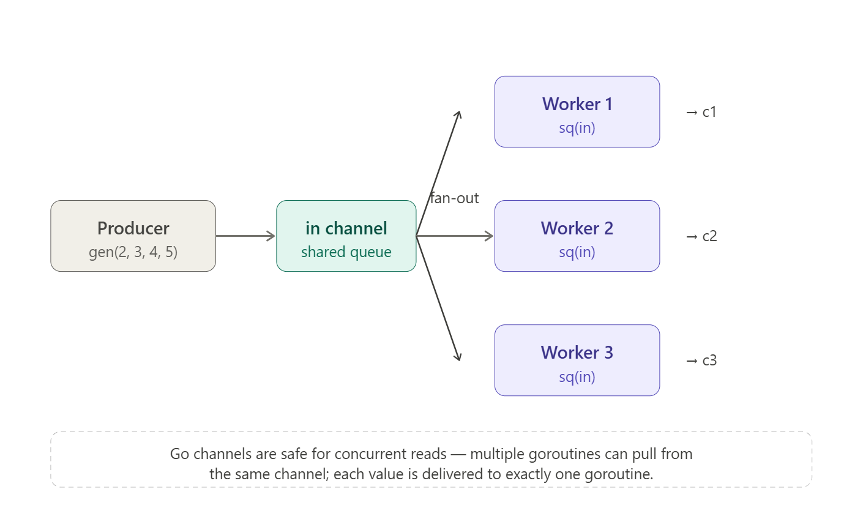
in := gen(2, 3, 4, 5) // one shared input channel
// Fan out — all three read from the SAME channel
c1 := sq(in)
c2 := sq(in)
c3 := sq(in)
Why use it? Without fan-out, items are processed sequentially. With fan-out, you parallelize CPU work and I/O across as many workers as you need.
package main
import "fmt"
func gen(nums ...int) <-chan int {
out := make(chan int)
go func() {
for _, n := range nums {
out <- n
}
close(out)
}()
return out
}
func sq(in <-chan int) <-chan int {
out := make(chan int)
go func() {
for n := range in {
out <- n * n
}
close(out)
}()
return out
}
func main() {
in := gen(2, 3, 4, 5)
// FAN-OUT (2 workers)
c1 := sq(in)
c2 := sq(in)
// Consume each separately
for n1 := range c1 {
fmt.Println("c1:", n1)
}
for n := range c2 {
fmt.Println("c2:", n)
}
}

Fan-In:
Fan-in is the inverse of fan-out: multiple input channels collapsed into one so the downstream consumer has a single place to read from
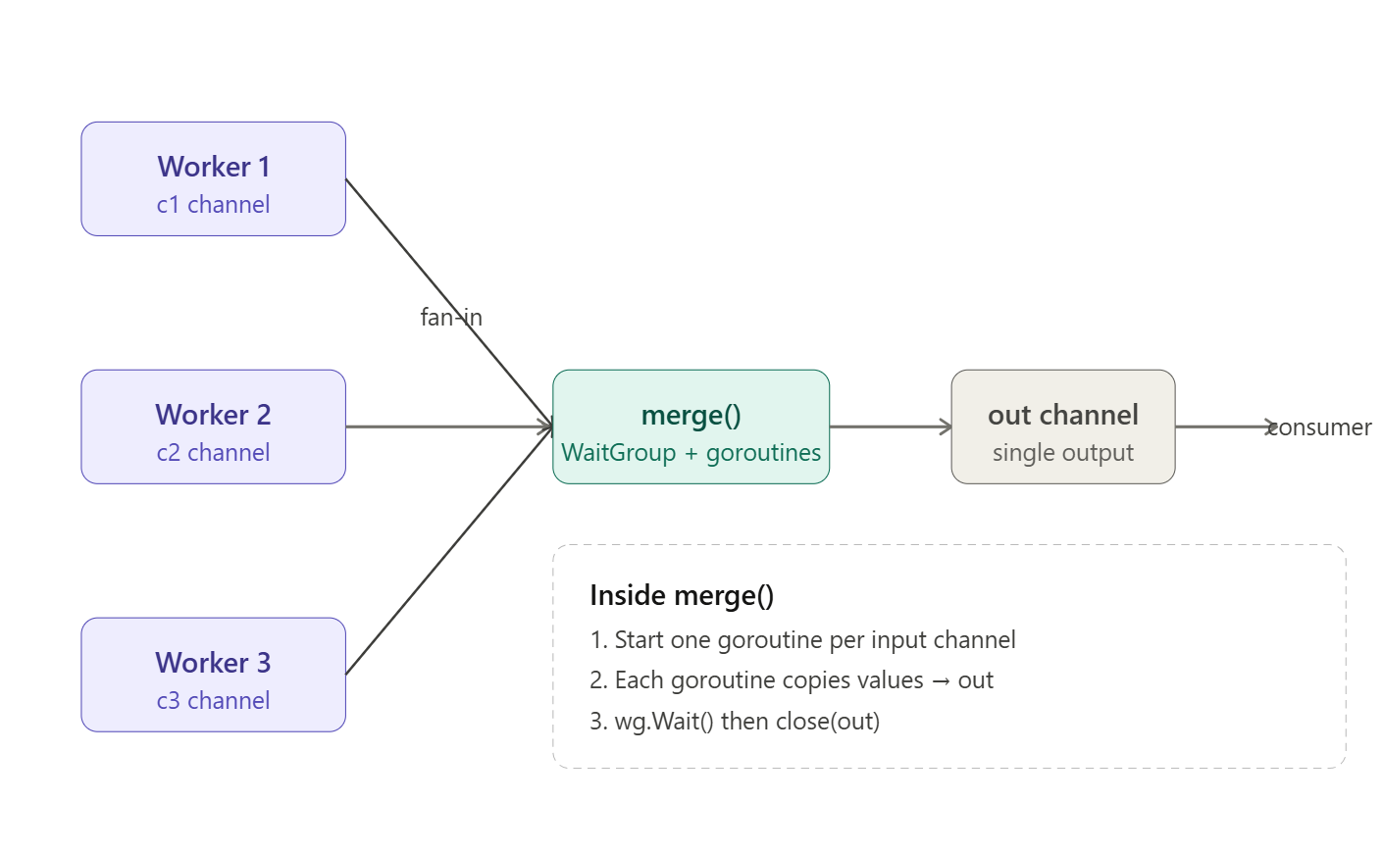
Fan-In = Combine multiple input channels into ONE output channel
c1 ──\
├──> merge → out
c2 ──/
package main
import (
"fmt"
"sync"
)
func gen(nums ...int) <-chan int {
out := make(chan int)
go func() {
for _, n := range nums {
out <- n
}
close(out)
}()
return out
}
func sq(in <-chan int) <-chan int {
out := make(chan int)
go func() {
for n := range in {
out <- n * n
}
close(out)
}()
return out
}
// FAN-IN: merge channels
func merge(cs ...<-chan int) <-chan int {
var wg sync.WaitGroup
out := make(chan int)
wg.Add(len(cs))
for _, c := range cs {
go func(ch <-chan int) {
defer wg.Done()
for n := range ch {
out <- n
}
}(c)
}
go func() {
wg.Wait()
close(out)
}()
return out
}
func main() {
in := gen(2, 3, 4, 5)
// FAN-OUT
c1 := sq(in)
c2 := sq(in)
// FAN-IN
out := merge(c1, c2)
// Single consumer
for n := range out {
fmt.Println("merged:", n)
}
}

